36th Annual Keres Memorial
May 20-23, 2011 BC Canada
$4000 Guaranteed Prize Fund

Come play chess in Vancouver on the May long weekend.

A 7 round Swiss with a guaranteed prize fund of $4000!

www.keresmemorial/pbworks.com
for updates, more information and online registration.

2011 Keres Memorial Chess Tournament

Playing Site: Capilano Room, River Rock Casino Resort, 8811 River Road, Richmond, BC.
Sections: Open (FIDE, CFC rated),U2000 (CFC rated), and U1600 (CFC rated)
Rounds: Rd.1 Friday May 20, 6:30pm, Rd.2 and Rd.3: Sat. 10:00am, 5:00pm; Rd.4 and Rd.5: Sun 10:00am, 4:00pm; Rd.5 and Rd.6: Mon. 10:00am and 3:00pm.
Prizes $4000 Guaranteed Prize Fund! Open Section: $1000, $600, $400 Top BC player qualifies for BC Closed U2200: $300, U2000 Section: $600, $400, U1800 $200 U1600 Section: $300 U1400: $100; Top Unrated Score (any section) $100
Time Control Game in 80 minutes plus 60 second per move increment.
Entry Fee
GM, IM, WGM free if registered on/before May 17, else EF deducted from prize.
(Open) $120 on/before April 8, $130 on/before May 17, $140 on site.

(U2000) $100 on/before April 8, $110 on/before May 17, $120 on site.

(U1600) $80 on/before before April 8, $90 on/before May 17, $100 on site.
Accommodation: At the River Rock Casino Resort: $129/night single/double; 8811 River Road, Richmond BC; 1-866-748-3718. Rate is guaranteed to April 20.
Transportation:
- By car – free parking.
- By Sky Train or bus to Bridgeport station
- By Air – 5 minutes from Vancouver Airport by SkyTrain or taxi.
- By boat to the River Rock marina.
Registration: Online at www.keresmemorial.pbworks.com , or by email to VictoriaChessClub@gmail.com , or by mail to Roger Patterson, 4381 Wildflower Lane, Victoria, BC, V8X 5H1, or in person at the Victoria Chess Club or on site May 20 until 9:30. Cheques payable to Roger Patterson. Registration after 6:30 does not guarantee a Swiss pairing.
Misc: Clocks and sets provided. Up to 3 half point byes if requested in advance for rounds 1-6. The BCCF Annual General Meeting will be held between rounds 1 and 2 at 3:00 pm. Unrated players are not eligible for class prizes. BCCF membership included in entry fee. Non CFC members must purchase a Tournament Membership ($16 adult or $8 junior).
FIDE and CFC Rated

Top B.C. finisher will qualify for
the BC Closed.

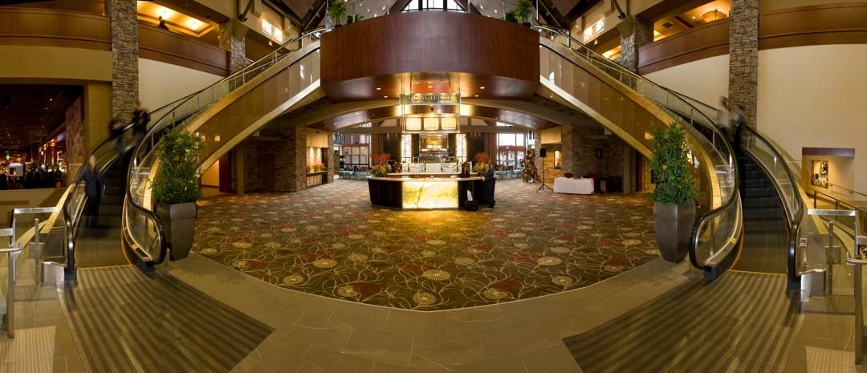
The tournament will be held in the River Rock Casino Resort in Richmond B.C.
www.riverrock.com

We hope to see you at the 2011 Keres Memorial – BC's traditional main event of the year! Please spread the word about this event. The River Rock Casino Resort is offering a great rate of $129/day which can be extended for 3 days before and after the event.
Reserve your room now by calling toll free 1-866-748-3718
Reserve by April 20 to guarantee this rate.

For Information contact
VictoriaChessClub@gmail.com

www.keresmemorial.pbworks.com

Organizing Committee
Roger Patterson
Brian Raymer
Paul Leblanc

TD
Stephen Wright

Name: _____________________________ Phone:_________________________

Address: ___________________________________ (street address)

___________________________________ (city)

___________________________________ (province, state)

e-mail address ____________________________________

Rating: ________(FIDE) _______ (CFC) ________ (FQE)

_________(USCF)_______(CMA) Applicable membership no. ___________

 | On/Before April 8 | On/Before May 17 | On Site | Amount encl.
Open | $120 | $130 | $140
U2000 | $100 | $110 | $120
U1600 | $80 | $90 | $100
Non CFC member adult | $16 | $16 | $16
Non CFC member junior | $8 | $8 | $8
 |  |  | TOTAL

Mail registration form and cheque to:
Roger Patterson, 4381 Wildflower Lane, Victoria, BC V8X 5H1
Do not mail cheques on or after May 10 Registration on or after May 10 online or email only .
Information VictoriaChessClub@gmail.com
Cheques to made Payable to Roger Patterson. Checks in US funds accepted.

